**How To Excel In Group Talks**

**What is a GD?**

* A group discussion, also known as a GD, is a technique that helps business organisations, educational institutions, and other companies to judge a candidate’s soft skills.
* It involves the participation of a group of people who are asked to discuss different aspects of a topic given by the interviewers.
* It is a conversation among participants about a specific topic.
* The candidates discuss the assigned subject to present information, viewpoints, and conclusions.

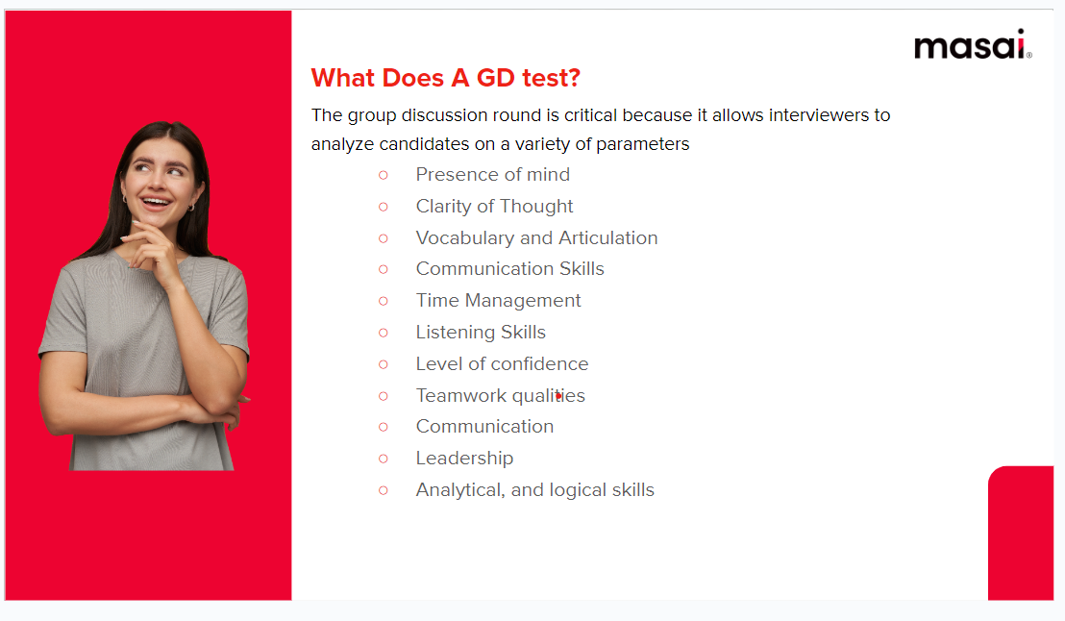

**Who gets selected in a GD?**

* The person who expresses ideas well.
* The person with sound arguments, demonstrating keenness and interest.
* The person who has sufficient knowledge of the subject and is able to convince.
* The person who applies a logical and systematic approach.
* The person who has a positive attitude and is also assertive
* Most importantly the person who has the tendency to cooperate and who coordinates with the group

**How to Initiate a GD?**

* There is always an advantage if the initiation is perfect as an opening. However, it doesn’t mean that one has to start first whenever one starts 1st or 2nd or 5th or in any order if one can initiate his views below the impact will be positive.
* Initiating a GD is a high profit-high loss strategy.
* Initiate one only if you have in-depth knowledge about the topic at hand.
* Do not stammer/ stutter/ quote wrong facts and figures.

**Do’s and Don’ts**

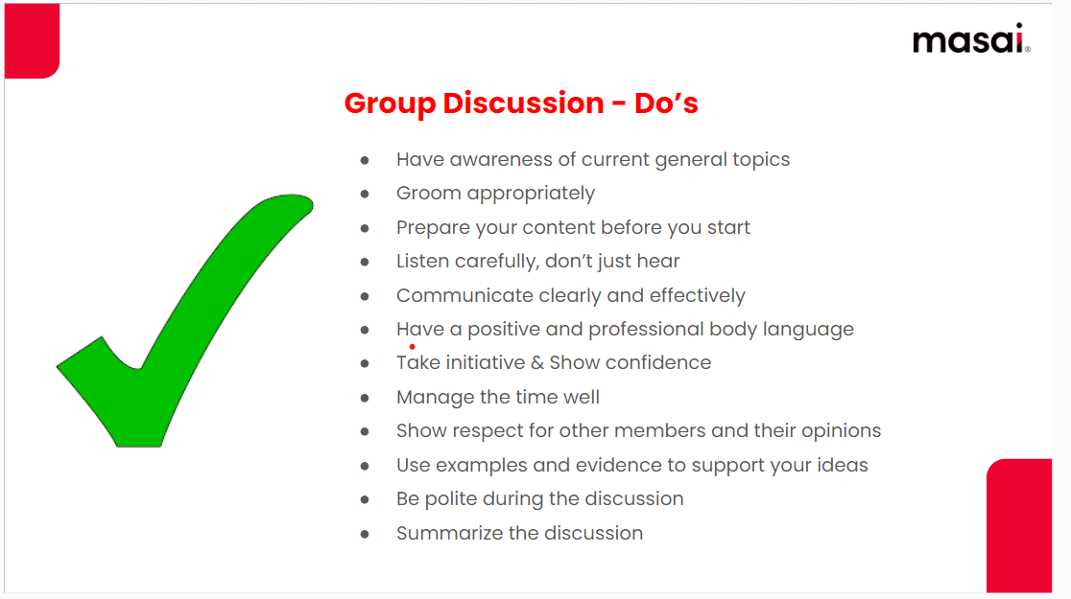

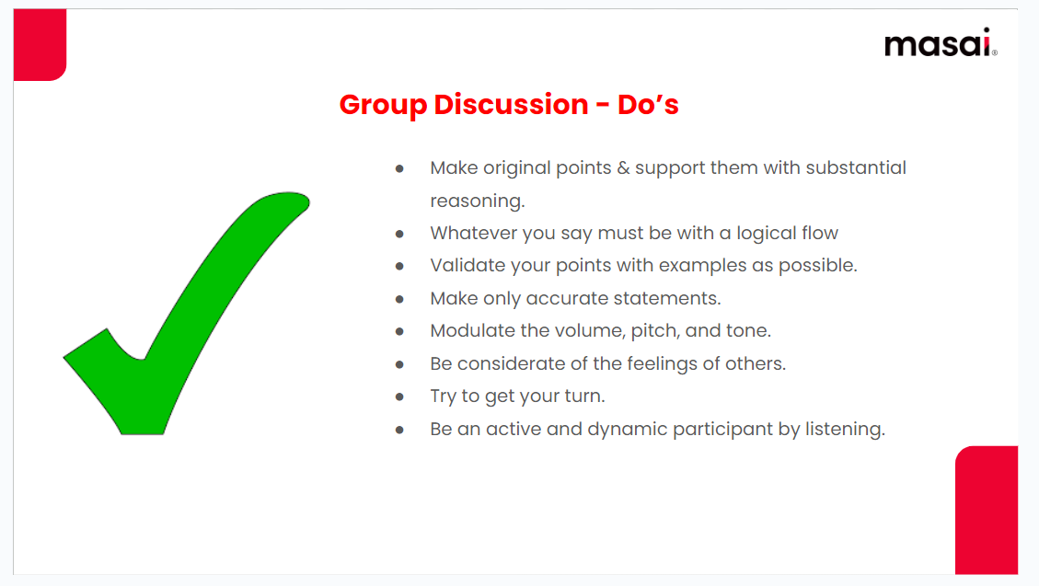

**Don’ts**

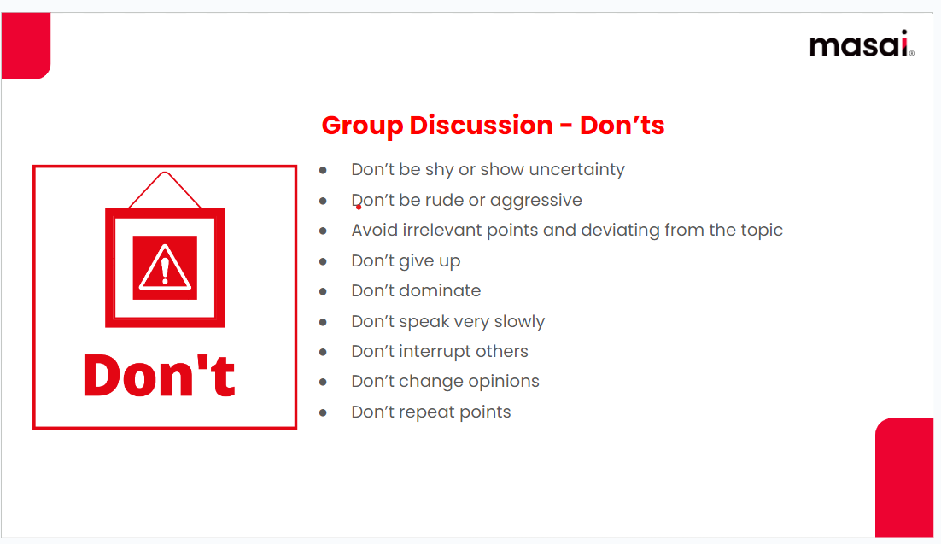

**How To Approach Group Discussions?**

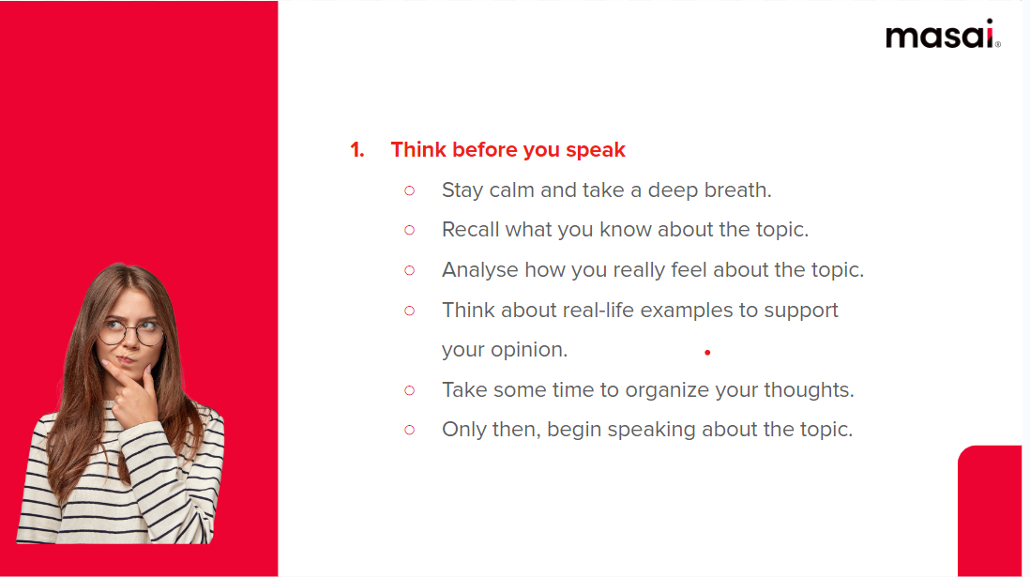

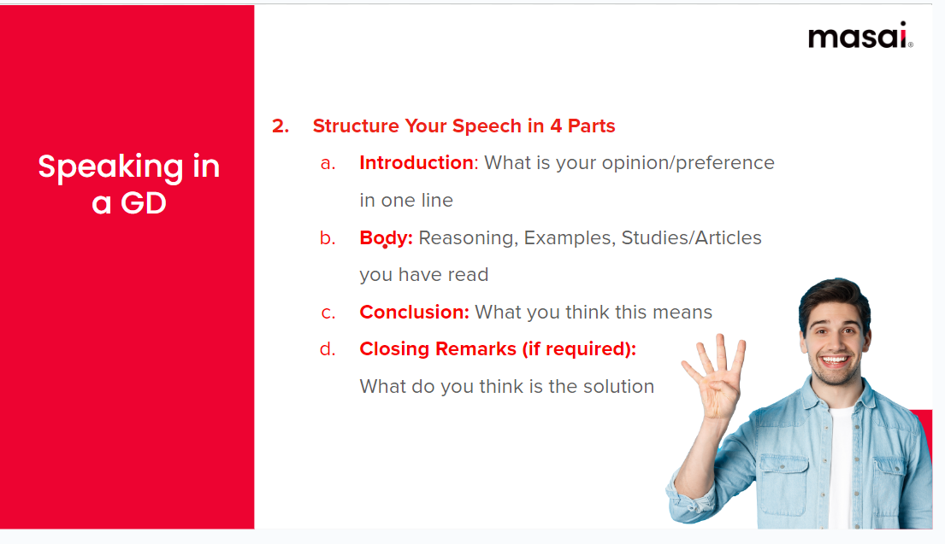

**Phrases for Speaking in a GD**

**Part 01: Introduction**

* I believe social media is harming our youth because it is designed to be addictive.
* I think a 4-day work week is not required since most people are working from home nowadays.
* I would choose startups over MNCs because I think the work is more challenging.

**Part 02: Body**

* In my experience, seeing Instagram posts of others often makes me feel depressed. I have read many articles that say overuse of Instagram is correlated to growing cases of depression among teenagers.
* Personally, I have noticed that working from home has reduced my overall working hours. I think this is because I am more efficient when I’m at home.
* Many of my friends are working with startups. I have noticed them build a great overall understanding of how companies function. I don’t see the same happening with my friends working in MNCs.

**Part 03: Conclusion**

* In conclusion, there seems to be sufficient evidence that suggests social media does more harm than good.
* As a result, work hours have effectively reduced. Therefore, I believe a 4-day work week is not required.
* It’s easy to see how working with startups builds well-rounded professionals. This is why I would prefer working with startups.

**Part 04: Closing Remarks**

* Going forward, I think it’s important to build awareness among young people about how social media might be affecting them.
* I am, however, speaking on the basis of my personal experience. I understand that this might not apply to everyone.
* I do understand that most startups don’t pay as well as MNCs. But personally, I believe I can afford to take some risks at this time.